Sun Auto – edgebootPro

Fortinet Installation Runbook

Before Arrival
- Read this document
- Note the name and telephone number of the Manager on Duty
- Note the network connection positions
- Note the device power connection positions

Upon Arrival
Locate new Granite equipment shipped to site. It should be labeled with “Hold For Granite Telecom Technician” tape.
- Introduce yourself to the local Sun Auto Manager on Duty (MOD)
- Document the current condition of the equipment rack by taking pictures before beginning any work.
- Technician to equip themselves with the following:
  - Safety glasses
  - Non-slip closed-toe footwear
  - Laptop with an RJ45 port
  - Patch cables for testing
  - 6 foot Ladder
  - Fish Tape
  - Drill
  - Velcro Straps
  - Phillips, Slotted and Torx bits
  - Label maker
- Familiarize yourself with the workspace and identify the core components for today’s Turn-Up

Equipment for the installation
- (1x) edgebootPro
- (1x) edgeboot+
- (1x) Console Cable
- Patch cables for testing
- (10x) Tie downs /straps/zip ties for cable management
- (1x) External mounted Taoglas antenna P/N TGX.45.A.B1.01
- (2x) Antenna cables P/N LMR400-20-SMSF
- (5x) Six-inch extension cords P/N SW-30376-5P (SEWELL6-PWR)
- Shelf for edgebootPro P/N CABSHELF116V
- Return label for Cradlepoint
- Return box for Cradlepoint
- Box for old NID

Prior to joining bridge
Open the box and verify that you have received the parts above. Please join the bridge at the scheduled time.
- The call bridge information is provided in the Granite ticket. Dial in.
- The new equipment must be unboxed, staged, and cataloged to make sure all parts have been received.
- DO NOT make any connection to the existing network switch at this stage. Install the edgeboot mount kit for the edgebootPro in the rack if possible.
- Without disturbing power or any connections, stage the edgebootPro and edgeboot+ near the rack per provided diagram prior to de-installing the current equipment. You will install the edgeboot devices in the rack in a later step.
- Have the technician on the bridge verify that the location Meraki devices and the edgebootPro are accessible remotely prior to moving forward with de-installation of the old gear.

Assembling the edgebootPro and edgeboot+
- DO NOT make any connection to power or the existing network switch at this stage.
- Ensure the clear pull-tab on the edgebootPro SIM has been removed. If it has not, please remove it and document this in your notes.
- Install edgebootPro and edgeboot + and keep in mind that they connect via a dedicated port on the side of both units with interlocking tabs. The port is covered with a protective plastic cover. Make sure to connect both units as shown in the picture below:
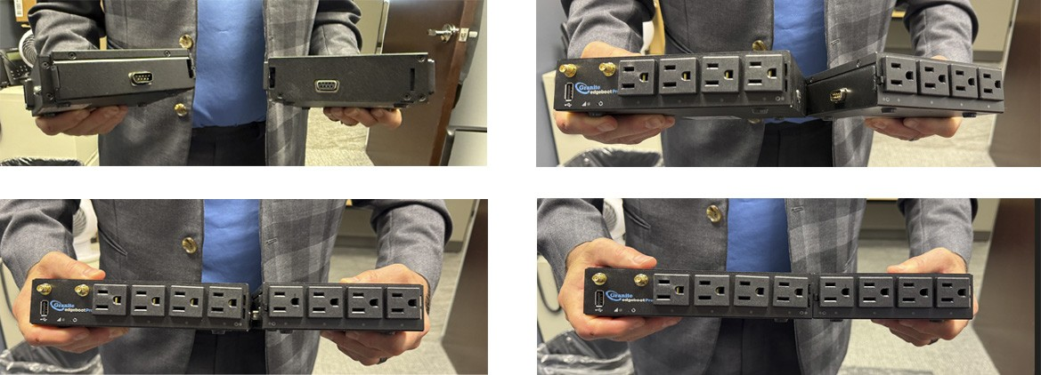
Figure 1 - Attaching the edgebootPro and edgeboot +

- While reviewing power connections it is critically important to wait till the appropriate step in this document before any power is disconnected. Some devices (Broadband Modem, FortiGate FG-60F, etc.) may have a power plug that has the power brick at the end of the power cable that may cause crowding on the power receptacles on the edgebootPro. Granite has included five 6” extension cords to plug in these devices to the appropriate ports. The extension cords may vary. See picture in Figure 2.

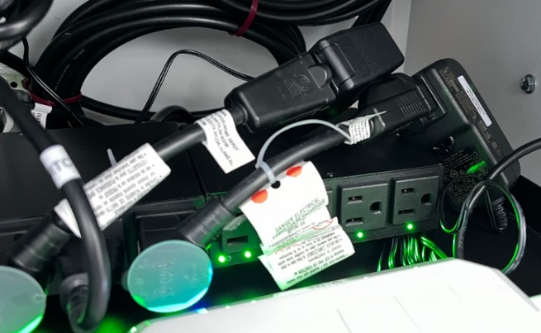
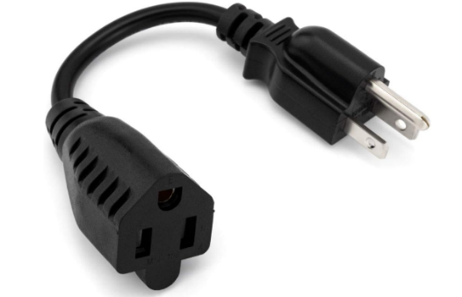

Figure 2 - edgebootPro with 6" extension cords (Left)

Antenna and Cable Installation
The Taoglas antenna (P/N TGX.45.A.B1.01) and cables (P/N LMR400-20-SMSF) will need to be installed to move the cellular antennas outside of the rack. The LMR cable length is 20 feet long. The antenna includes a wall mount bracket. Mounting the antenna can be a time-consuming task.
Begin by surveying the site and finding an area where the antenna will be closest to an outside wall that yields the best cellular reception possible. Once that location is chosen, you can mount the antenna as needed. It is not permitted to penetrate an outside wall, but if appropriate an inside wall can be penetrated with the antenna and cable fixed above the dropped ceiling.

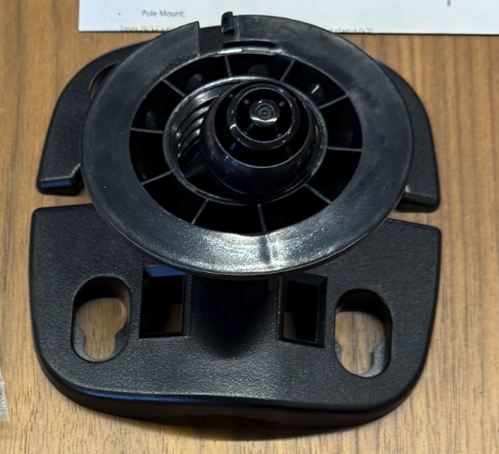
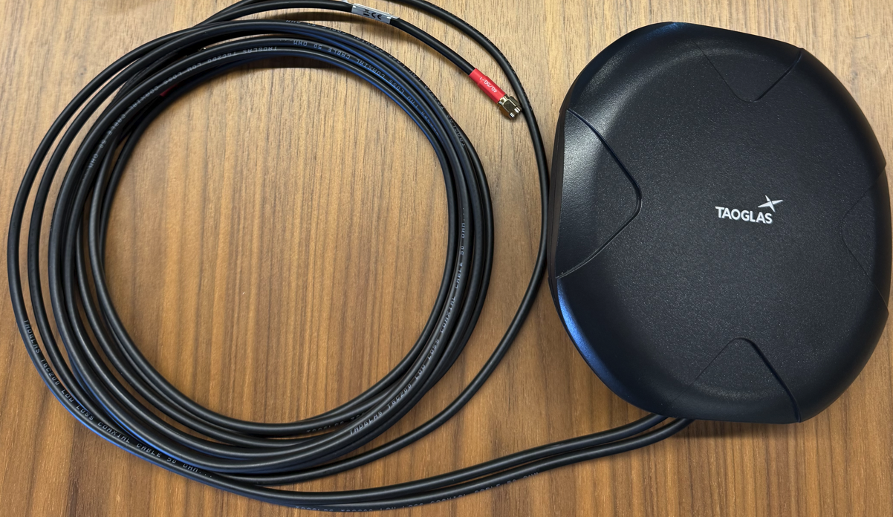
Figure 3 - Taoglas Antenna with built in 3 meter cable (Left) and Wall Mount Bracket (Right)
Attach the antenna to the wall mount backet (see figure 3). The antenna has a 3-meter cable built in with a red sheath on the male SMA connectors that says 4G/5G-1 in white letters. You will need to install the LMR extension cable to the Taoglas antenna and the edgebootPro for added length. Included are two P/N LMR400-20-SMSF cables. Attach the antenna male SMA connectors with the red 4G/5G labels (see Left picture on Figure 4) to the extension cables Male SMA cables (see center picture on Figure 4 below). The completed assembly is on Figure 4 right.
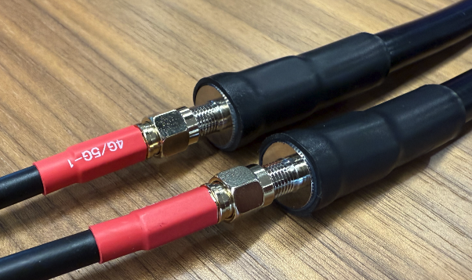
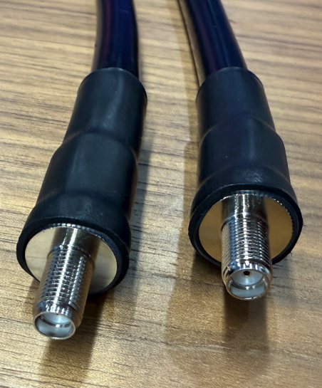
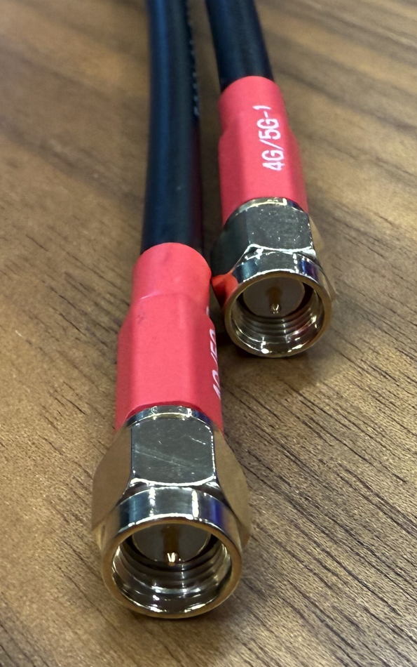
Figure 4 - Antenna Female SMA Connectors (Left), LMR Cable Male SMA Connectors (Center)
and Completed Connection (Right)

Connect the extension cable’s female SMA connectors (see Figure 5 Left picture) to the edgebootPro LTE MIMO brass colored male SMA connectors (see Figure 5 Right picture).

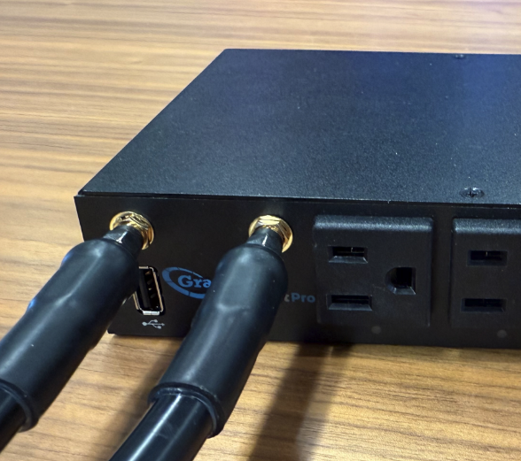
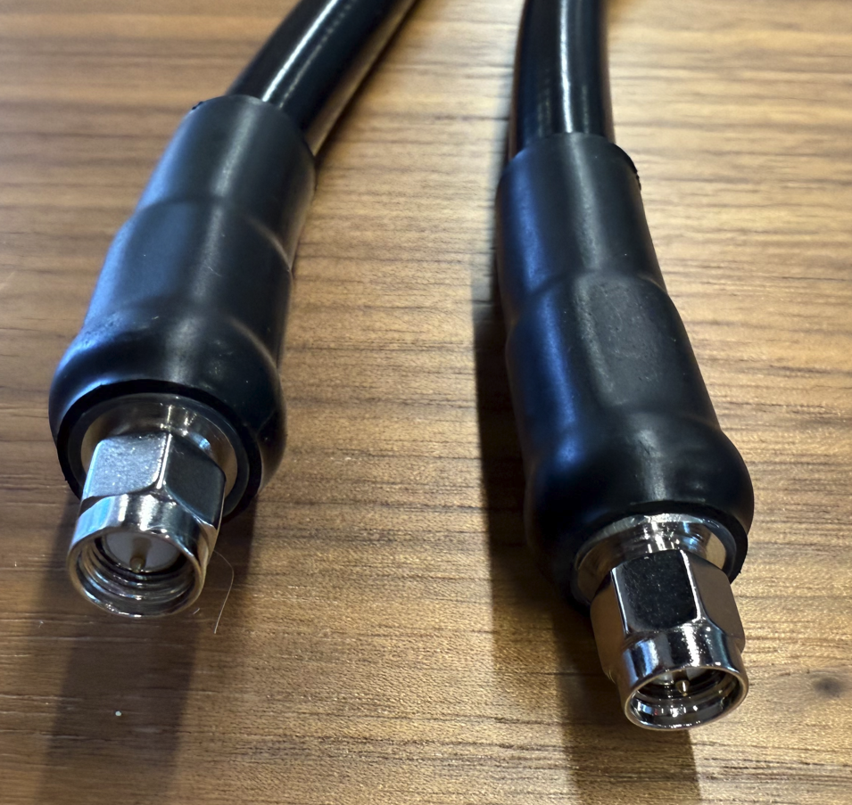
Figure 5 - LMR Cable Female SMA Connector (Left) and Cables Connected to the edgebootPro (Right)
After the final placement of the antenna and routing of the cables to the cable rack, use the tie down straps to secure the antenna cables. Proceed installing the edgebootPro and edgeboot+ into the rack.
- Power the edgebootPro. You can test the location of the antenna by using LTE signal strength indicator light. See chart below for edgebootPro LED indicators for reference below.
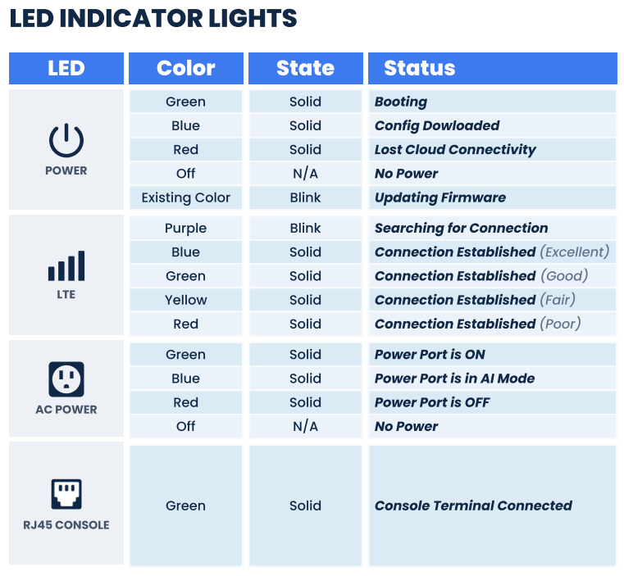
- The goal is to achieve a Green (good connection) minimum with Blue (excellent connection) preferred.
- Once all devices have been installed on the rack, proceed to Port Mapping guide shown in Figure 3.


Perform a speed test by plugging directly into the edgebootPro port Eth1 with your laptop. Record the speed test while plugged in directly into the edgebootPro. If the speeds are satisfactory with the Granite tech on the bridge, record the speed tests and proceed to the next step, cutting over.

Console Cable
- Connect the Edgeboot console cable from the edgeboot console port to the Fortinet 60F
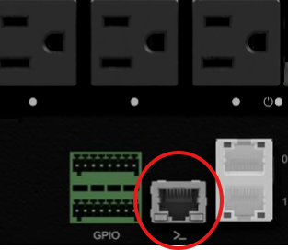
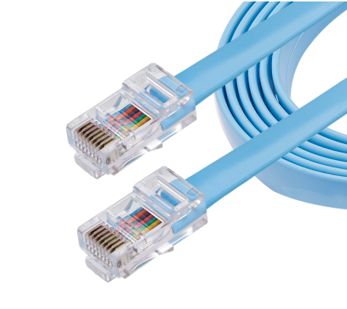
- The console cable will connect to the Fortinet 60F Console port.
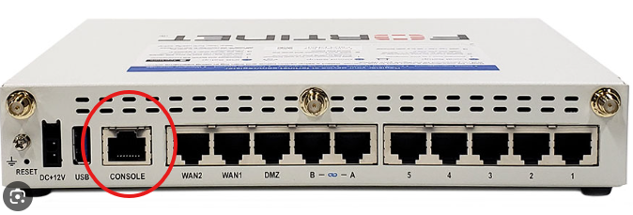

Cutting Over
- Make sure the engineering team on the call has access to the FortiGate device through the Fortinet portal prior to inserting the edgeboot into the rack.
- The Field Technician will be installing the edgebootPro and edgeboot + into the rack when queued by the engineer on the call.
- Alert the local contact that the site will be going offline for 30 minutes
- Power down the FG-60F and other devices that need to be plugged into the edgeboot device and move the power plugs to the respective power ports as stated in Port Mapping Legend (Figure 6) shown below:
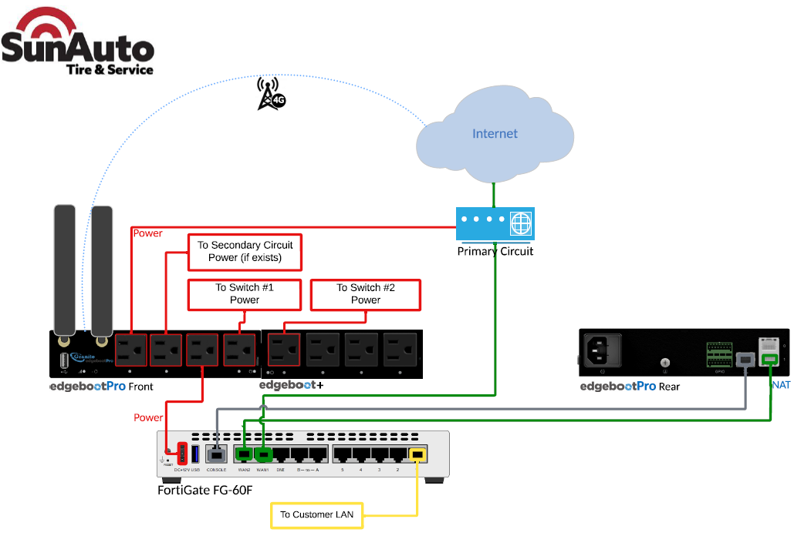
Figure 6 - Port Mapping Diagram
Install the power from the FortiGate, Switch, Broadband Modem other devices to the edgebootPro. Make sure to plug the devices into the following ports:

edgeboot Pro – Port Mapping Legend
Port | Device
Console | To FG-60F Console Port (Console Cable)
Eth0 | Unused
Eth1 | To FG-60F WAN Port 2
Power 1 | To Modem #1
Power 2 | To BB Modem #2 (for 2 modem solution)
Power 3 | To FG-60F
Power 4 | To Switch #1
Power 5 (edgeboot +) | To Switch #2 (if exists)

- After cabling and powering up the equipment the technician will inform the Granite Engineer on the phone that the equipment is ready to be accessed remotely.

Solution Checklist
The Granite Engineer on the bridge will verify that the FortiGate and SD WAN tunnels are up.
- Ensure that any devices or cables that have been moved or adjusted are secured with tie-down straps.
- To connect to network switch, please run a patch cable from an open port on the switch to your laptop. This will connect you to the LAN. Please record your DHCP address and perform the speed tests through your wired connection. Record and screenshot the results.
- The field technician will test the primary internet circuit by doing multiple speed tests and recording the speed test results. Screenshots should be provided as part of the closeout pictures and can be posted on the call bridge also. The field tech must plug into the network switch to test with their laptop. **Please do not instruct the Sun Auto personnel to test from their Thin Client desktop as the speed will be from the data center, not the local internet**
- To connect to network switch, please run a patch cable from an open port on the switch to your laptop. This will connect you to the LAN. Please record your DHCP address and perform the speed tests through your wired connection. Record and screenshot the results.
- A failover test can be done by unplugging the primary internet from the FortiGate WAN1 port and failing over to the edgebootPro. At this point, the technician will do another speed test and record the results. Screenshots must be provided as part of the closeout pictures.
- The primary internet connection will be plugged back into the FortiGate WAN1 port. The FortiGate will normalize the connection before restoring traffic to the primary connection. This process can take up to a minute, and it is normal to avoid switching traffic to a flapping connection.
- Perform another speed test (while still plugged into the network switch) after the circuit is back up and normalized. Record the speed test and provide screenshots for the closeout notes.
- Check with the local contact to make sure they can test their applications such as quotes, invoicing, printing, credit card transactions and VoIP phone usage. A complete list is available in the next step as part of the Post Installation – Technician Deliverables step.
- Remove and box the Cradlepoint for shipping if the site has a Cradlepoint.
- Remove, box and lable the old NID for the store manager.
- Once the local contact has performed all tests successfully, record the results and proceed to collect the post installation deliverables.
- Please collect and dispose of any waste left over from this installation.

Post Installation – Technician Deliverables
Fully complete the Sun Auto Sign Off checklist above (Any items not tested and checked off will be considered incomplete and may result in a return visit)
The field tech will upload all deliverables below via the link provided on the equipment ticket.
- Picture of equipment installed – edgebootPro and edgeboot + (Close Up)
- Picture of equipment installed – edgebootPro and edgeboot + (Wide)
- Picture of the complete cabinet (Close Up)
- Picture of the complete cabinet (Wide)
- Pictures of the antenna wiring
- Pictures of the speed tests taken on the primary circuit
- Pictures of the speed tests taken during failover on the edgebootPro
- Pictures of the speed tests taken during the failback to the primary circuit
- Test and screen capture (Sun Auto personnel will perform these tests)
  - Vast Connectivity
  - Reprint Invoice
  - Access Paycom
  - Internet Access (Surf)
  - Phone Connectivity
  - Credit Card Transaction
- Please make sure that the Sun Auto local contact has completed testing all applications successfully prior to departure.
- Record and escalate any nonstandard test results
- Collect, box and label the Cradlepoint for return to Granite
- Collect, box and label the old NID for the store manager
- The field technician MUST get a signature prior to leaving the site that all items are tested and completed!

Equipment Pictures
Solution Hardware
- (1) edgeboot Pro
- (1) edgeboot+
- (1) External Antenna TGX.45.A.B1.01
- (2) Antenna cables P/N LMR400-20-SMSF
- (5) Six-inch extension cords P/N SW-30376-5P (SEWELL6-PWR)

(1) edgebootPro
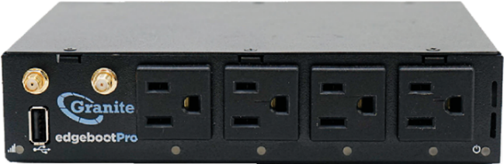
Front View
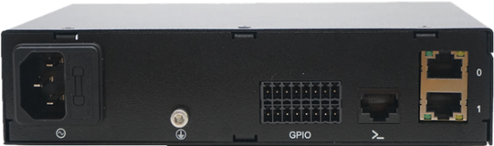
Rear View
(1) edgeboot +
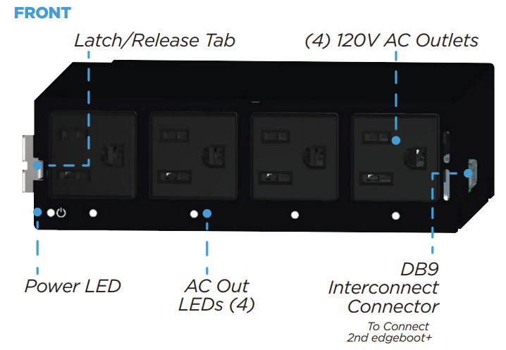
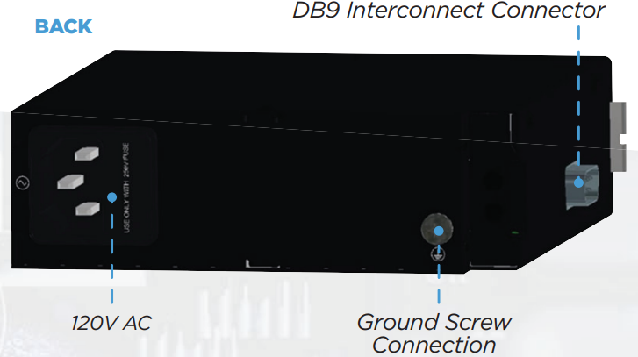

(1) Taoglas antenna P/N TGX.45.A.B1.01
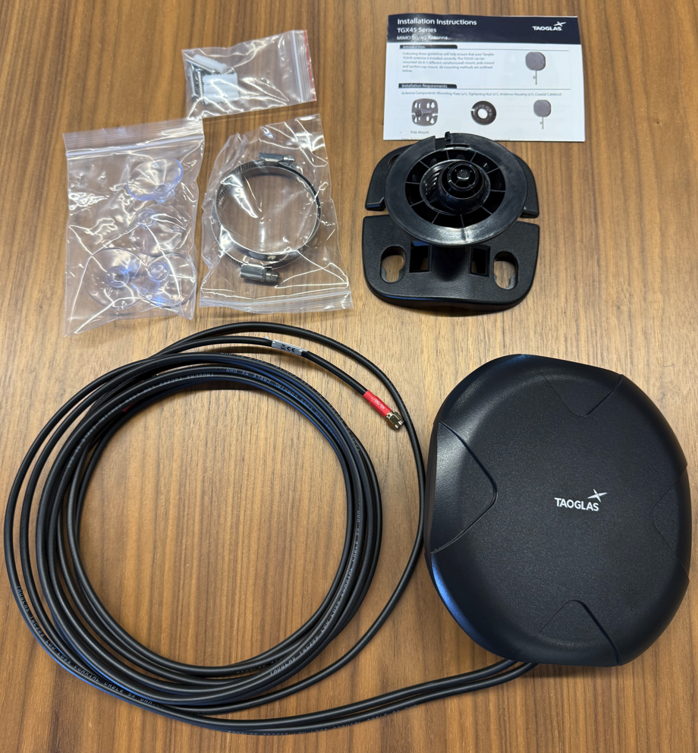

(2) Antenna cables P/N LMR400-20-SMSF

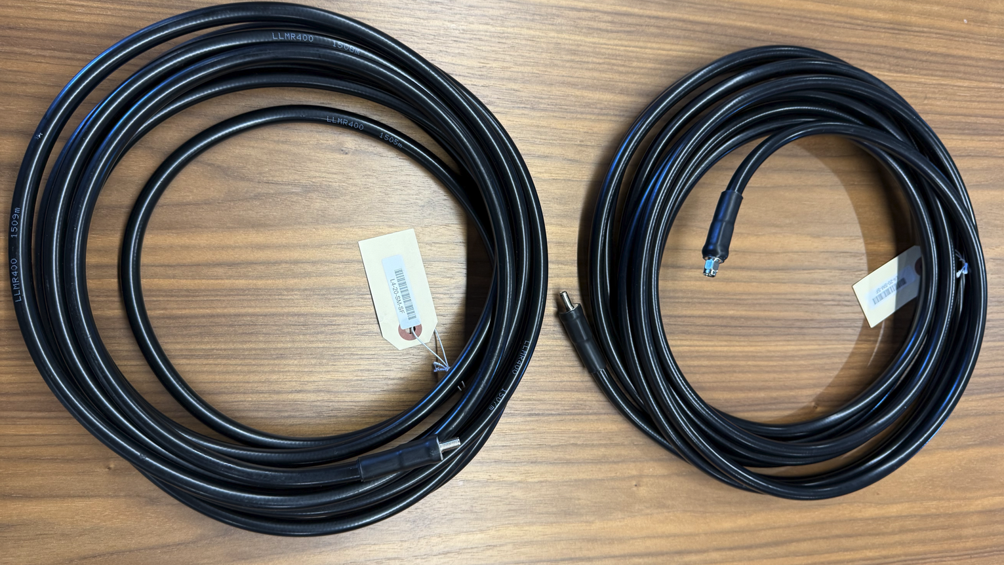

(5) Six-inch extension cords P/N SW-30376-5P (SEWELL6-PWR)
